ACADEMIA INTERNACIONAL DAVID


TECHNOLOGY
SUMMATIVE WORKSHOP # 5

NAME: __________________________DATE: ________________________________ 3^{rd Grade}: A B C
TEACHER: EDGAR PITTY
Name and date: 2pt |  | Follow Instructions: 1pt
Order: 1pt |  | Correct use of tools: 1pt
CONTENT: 25 pts |  | TOTAL: 30 pts

Part I: Circle with any color pencil only the parts of the robot we have seen throughout this course 1pt each, 7 points total. _____/7


Part II: Complete the word search below. Use color pencils 1pt each, 13 points total. _____/13.
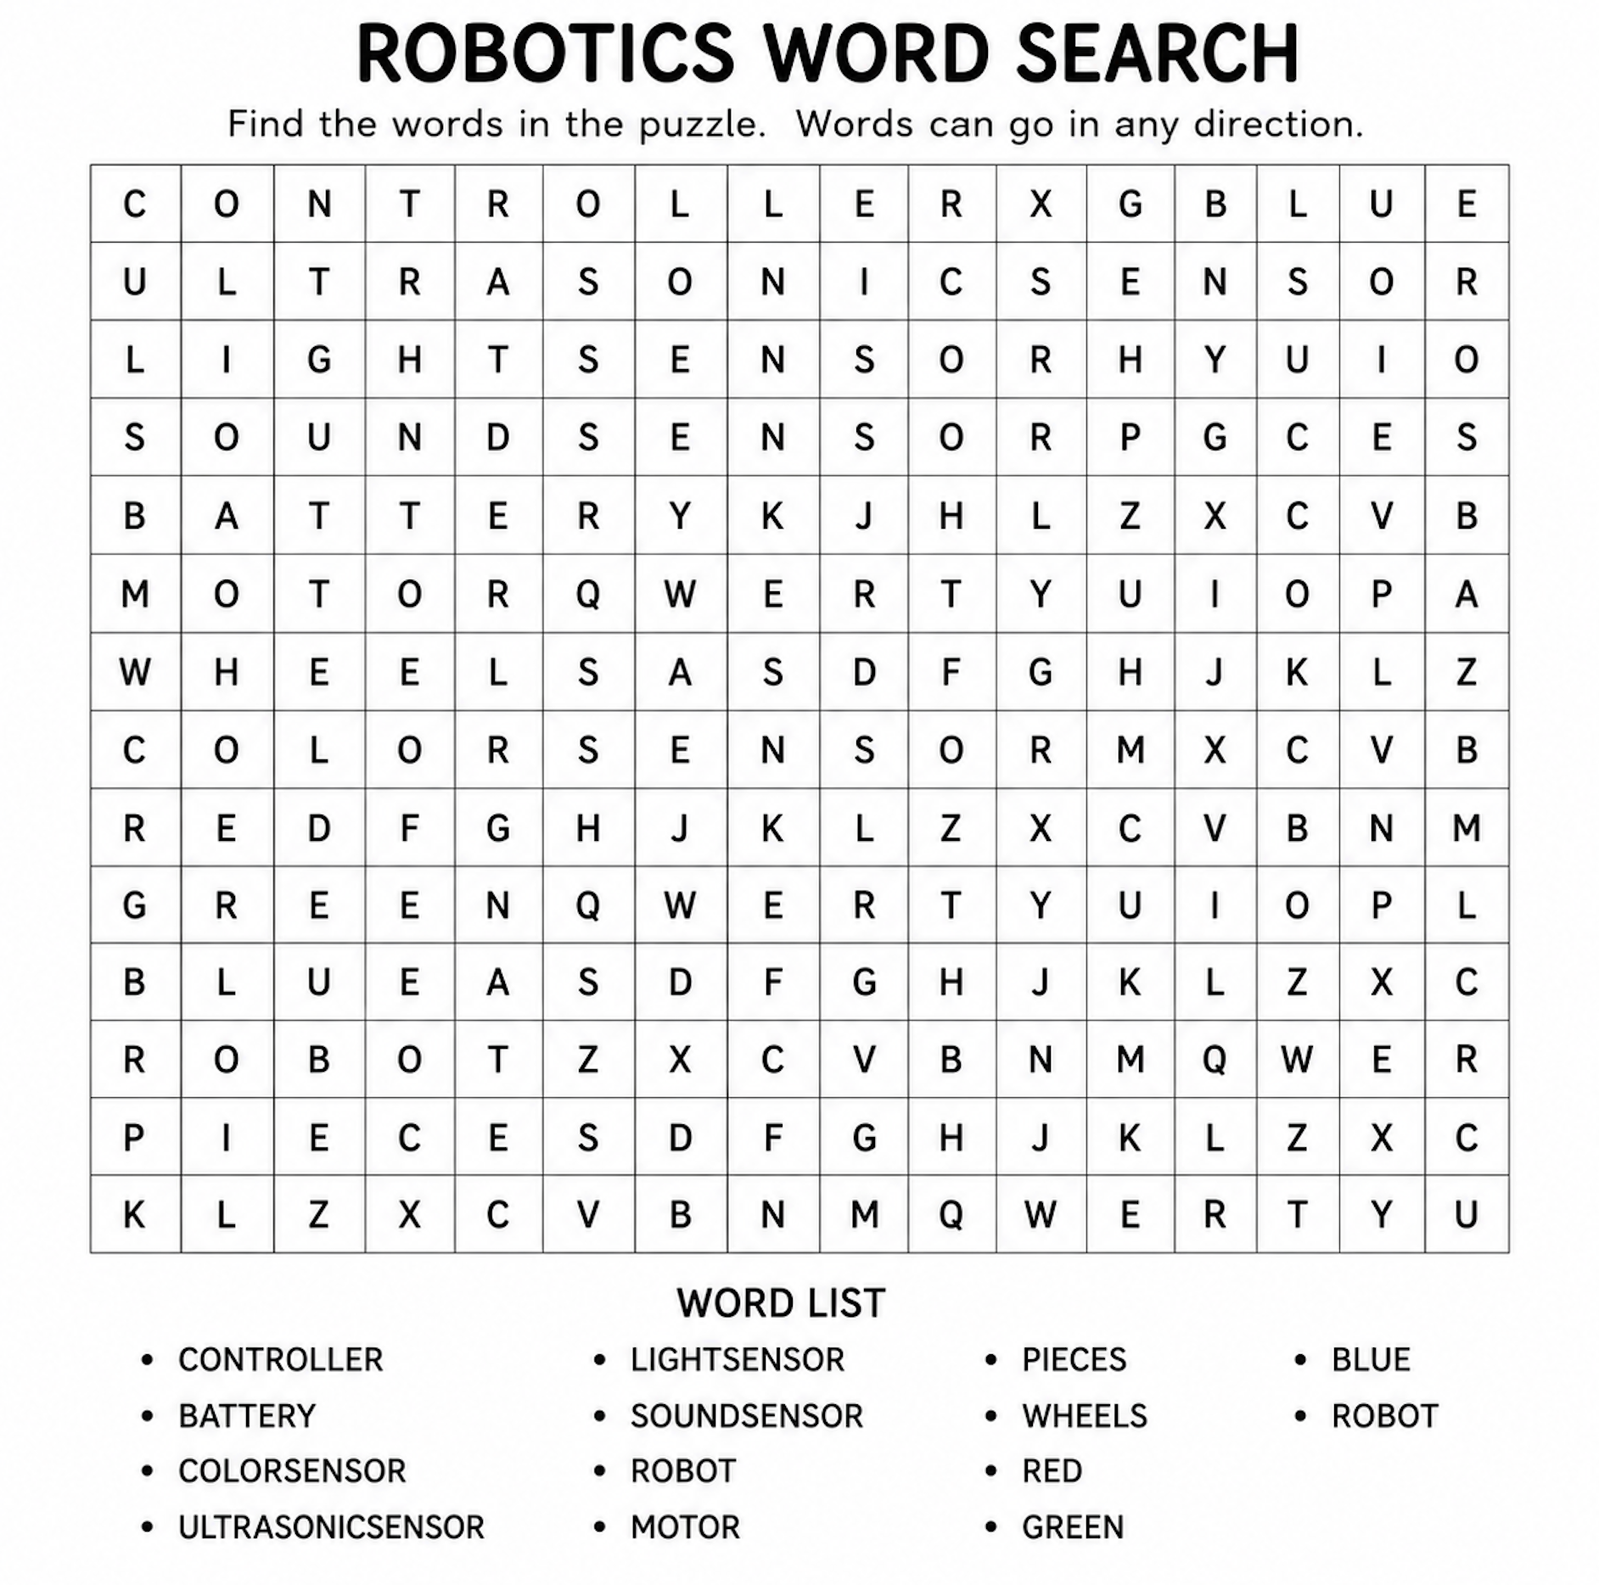
Part III: Complete the words below with the correct letters. 1pt each, 5 points total. _____/5.

- R __ B O __
- __ E N S O __
- B __ T __ E R Y
- P __ E __ E S
- C O N __ R O L __ E R

